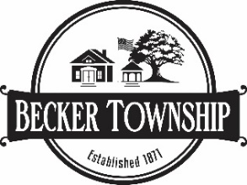
House Staking Certificate Information

If you are building a new home one of the following is required, signed by a registered land surveyor:
- A certificate of survey. If parcel is less than 5.0 acres, a certificate of survey is required.
- A site staking certificate is allowed when a parcel is 5.0 acres or greater in size. The site staking certificate is to show
  - The proposed building relative to the most restrictive setback
  - The proposed building relative to the most restrictive physical feature
  - The proposed low floor elevation (LFE) showing that the building will be a minimum of one (1) foot above mottling based on a soil boring.

Post Construction Verification is Required for all new homes.
After your new home is completed, a post construction verification survey, as-built certificate (site plan), is required, signed by a registered land surveyor.
Certificate is to:
- Show actual location of constructed structure relative to the most restrictive setback.
- Show actual location of constructed structure relative to the most restrictive physical feature.
- Show that the LFE is at least one foot above mottling.

The final approval or certificate of occupancy shall be withheld until such verification is given. Please allow one week for review of the as-built certificate.

As-built certificate to be submitted electronically to permits@beckertownship.org.

